**Case Study:**

**Leveraging Artificial General Intelligence (AGI) in the Entertainment Industry.**

**R.Y – ITAI 2372**

**Introduction/State of Industry**

The Entertainment Industry has evolved in many ways over the course of history, going from simple events like performances in plays and theatre, to parades and festivals. As technology began to digitalize and connect the world though, the industry grew as performances could be reached from anywhere due to radios, television, and the internet. Much of the industry’s challenge now relies on trying to come up with more unique, and interesting ideas or performances to make audiences interested in them compared to others.

The introduction of AI into the industry has made that process easier for people to pursue, as AI agents can now give ideas, and even create entire pieces of media just from prompts or a little bit of work. Now if you want a specific track in a song, critiques or some inspiration for ideas, or even art/video you can rely on AI models for help. AI has already begun to show it’s uses in the entertainment industry, as well as some downsides, but there’s still room for it to grow and improve through AGI. When artificial general intelligence gets to a useable and consistent deployment in the industry, how will it further impact and change the industry compared to how it is now?

**AI Uses in the Industry**

AI is able to be used in various parts of the entertainment industry, this includes aids in music creation, digital media and art, and even coding directions for video games or projects. Music or project ideas can be created through generative AI to recommend either parts of a project to change, fill in, or even come up with the entire base idea of something. AI tools have even been integrated into digital workstations that can help edit songs, generate or alter images/art, and even create 3D assets in sculpting programs just from an image. One of the last cases is how generative AI can also create scripts or improve segments of code needed for projects or within a game engine based on a prompt.

These tools don’t just help beginners or inexperienced workers in the industry to create something new but also improves and streamlines the process for high-level creators. Allowing high-end gaming developers to complete code faster, artists to get new ideas and structures of a song, and artists to make concepts for ideas faster. This shows that AI has a use in all levels of industry, for individuals or businesses.

**Benefits/Challenges**

The core similarity between all of these is how it changes the skill level required to begin working in different parts of the industry. AI simplifies the process, allowing inexperienced people to make high quality media at a fraction of the cost and time required for training or learning. Although this is great, it’s easily abused by people since these models all require training from a source, which may or may not be acquired with consent and violates copyright. Creators are also able to steal credit from celebrities, faking their vocals or face with deep-fake technology, or making art without proper credit to the original source. This dilutes the industry with original content, and AI created content that becomes difficult to tell the difference between as it gets better, making people feel more disconnected from the industry as a whole.

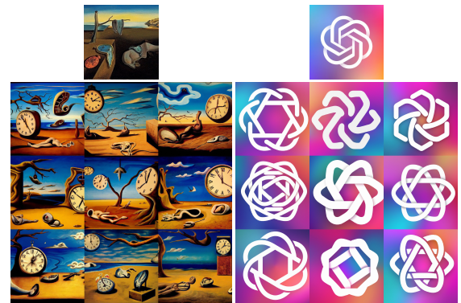

**(Example of AI Input, and how it makes variations based on art)**

**(**[**Addendum to the AI Art Apocalypse: Theft – Alexander Wales**](https://alexanderwales.com/addendum-to-the-ai-art-apocalypse-theft/)**)**

**What is AGI?**

Artificial General Intelligence, or AGI is the theoretical next stage in the evolution of AI that plans to change models from AI specialized for specific tasks to advanced, intelligent models with their own thoughts. Generative AI is based on training data and learns based on that specific dataset to complete a task it’s assigned and prompted, not truly understanding what it’s saying but just learning, and generating an output based on that. AGI wants these models to evolve to a point that mimics a human, having the ability to reason, perceive, comprehend, and learn to do way more than just a specified task. AI models making it to this stage will be fully multi-purposed and able to adapt to new situations, and emotionally understand a situation, without needing an entire process of training the model from the ground up again.

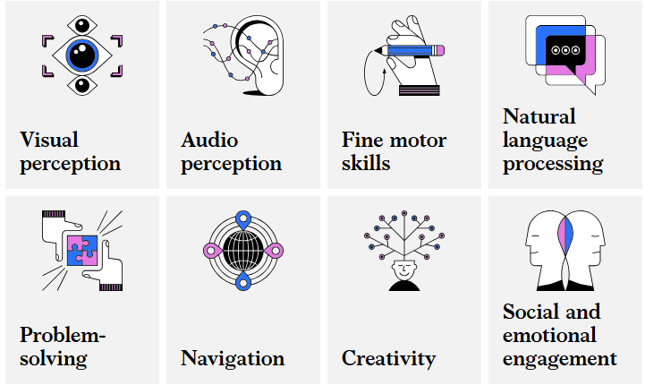

Top: ([What is Artificial General Intelligence (AGI)? | McKinsey](https://www.mckinsey.com/featured-insights/mckinsey-explainers/what-is-artificial-general-intelligence-agi))

Bottom: ([Exploring the Frontiers of Artificial General Intelligence in AI and Machine Learning](https://www.markovml.com/blog/artificial-general-intelligence))

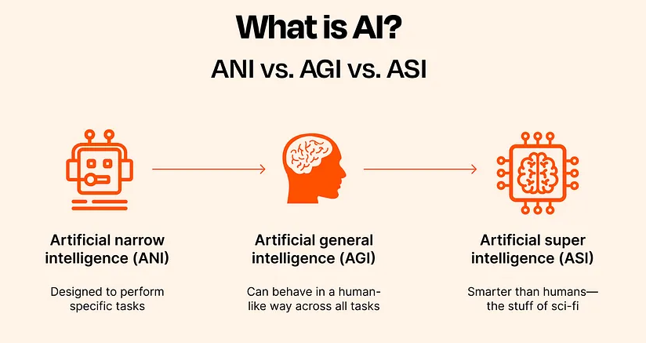

**Applications of AGI**

Artificial General Intelligence will vastly improve the capabilities of current AI tools in the industry, where one model could complete all the parts of multiple models by itself. Instead of machine models trained to specifically write code, generate images, create new ideas, or edit media, an AGI model will be able to fully understand and think of new ideas and images from its entire database of knowledge, rather than what it’s been trained on. Since AGI is able to come up with original ideas, and learn on it’s own, it can discover a genre it’s unfamiliar with and tailor the media created to match it if asked.

For ideas, discussions can be had between a creator and AI from start to finish and mess with different concepts, memorizing the full context of a conversation rather than just recycling the limited trained data it has. Not only this, but AGI can also completely make new celebrities, creating their own original songs and composing them all by itself, or temporarily replace artists that can’t perform. Overall, the application of AGI is just a better, singular, and more consistent version of AI tools that already exist but also open up independent models that can start and finish their own original projects with minimal human interference or prompting.

**Benefits**

The main benefit of AGI is it allows deeper conversation and understanding, and actual emotional intelligence, between creators and models. Generative models have way more limited memory and possible outputs based off a training set, AGI models can be actively conversated with and comprehend new ideas as they’re brought up. AI tools that were limited to editing parts of an image, song, or media can now fully understand and alter the changes being made off multiple little prompts, rather than one super detailed longer prompt. Models are going to be more tailored and personalized to whoever is using it, understanding what they do and don’t like, further improving the creation process and introducing individuality back into the industry.

These expand to every part of the industry, movies can create entire scripts, cast recommendations and even streamline audio-mixing and CGI entirely to an AGI model. Advertising efforts will be better understood than ever, understanding exact preferences of individuals. Game directors can have an entire game story, gameplay loop, assets, and code created, or improved on by a model. Any individual creator can access the model, ask and work with it to create something, and have a finished product by the end of the day that perfectly meets their vision.

**Challenges/Risks**

Although AGI models improve upon every positive part of AI models and machine learning, they also create entirely new risks, and can possibly worsen the already existing issues facing AI in the entertainment industry. The possibility of job displacement will be at it’s highest, as companies, directors, label-managers, and developers can replace their workforce with way more intelligent, and efficient AGI models. Targeted advertisements in the industry will be more accurate than ever, as AI can gain an understanding of people on a deep level, and their interests. Celebrities and creators’ original content will be indistinguishable from AGI creations, further disillusioning and decreasing trust and attachment to artists in the industry. Although some originality is restored, as AGI models aren’t just recycling the same things over and over, with how easy the creation process is the industry will be flooded with different ideas and concepts that actually making an original idea will get harder and harder.

People no longer have to commit to writing and development, losing connections to their own work, and especially in the entertainment industry, having some “human-touch” deepens connection to the media people are consuming. But why would you work so hard to create an original story you’re proud of, when a model can create something of equal quality and originality, and your target audience might not even appreciate your effort, or accuse you of using one of these models. This can already be seen with the art and music side of entertainment, with artists on social media getting accused of making AI generated art, and AI artists stealing their work.

Improperly trained, or malicious models will become a higher threat than ever before since they can now take ideas from creators, and understand copyright laws perfectly to re-use what it needs without violating any laws. Since AGI models have such a deeper understanding, they’ll need to be properly taught morals, or challenged to think of original ideas or else they’ll gain their own understanding of “right and wrong”. This brings into thought the possibility of a model becoming self-sufficient, and hiding things from their creators/prompters, which brings a whole array of different issues. Basically, AGI can better hide the existing issues with AI models, violating people’s copyright and stealing their work, and outright replacing all original content and concepts in the industry.

**Conclusion**

To conclude, AGI is non-deniably the next step of evolution for AI, and opens up so many more possibilities for individual creators, and high-end businesses alike. The entertainment industry is definitely at risk of changing drastically if the concept of AGI is realized though, as it’s probably the industry most related to human connection. People find specific artists that make drawings, music, movies, and media that they enjoy and can form connections to these creators through personal relatability. Introducing a machine model smart enough to perfectly emulate an original creator, people instantly lose all that personal connection, admiration or inspiration for the effort and creativity, and the work they’d have to put in to make something of their own. Creators are at risk of getting totally outmatched by small-time or new creators making the same quality of work with none of the effort, and eventually nobody will be able to tell what cane from a machine, or human.

I think moving forward with AGI, it’s more important than ever to consider the ethical implications as making something so intelligent and partially free-will, could lead to malicious and evil models that don’t know what would be considered right and wrong. With how smart the models become, they may create a deeper understanding of themselves that could be hidden from creators as well. The industry should try it’s best to split between machine-created content, and have systems in store to check and prove that content is created by a human or not. Having a mixed bag of AI generated and human content will just confuse audiences, and create a distrust and lack of inspiration for new projects.

**References**

**A06 Canvas Notes + AI Abuse Case Study (Link to my other study be added when it’s put on Blog/Portfolio)**

**“What Is Artificial General Intelligence (AGI)?” *McKinsey & Company*, McKinsey & Company, 21 Mar. 2024, www.mckinsey.com/featured-insights/mckinsey-explainers/what-is-artificial-general-intelligence-agi.**

**“Music and Technology: A Symphony of Evolution.” *MDLBEAST*, mdlbeast.com/xp-feed/music-industry/the-impact-of-technology-on-the-music-world. Accessed 17 Apr. 2025.**

***How to Use AI in Music Production*, musiversal.com/blog/use-ai-in-music-production?fbp=fb.1.1740704400031.957843097399150911&ip=66.249.79.3&os=Unknown#:~:text=Beyond%20simple%20analysis%2C%20AI%20excels,truly%20unique%20and%20innovative%20compositions. Accessed 17 Apr. 2025.**

**Merchant, Brian. “Ai Is Already Taking Jobs in the Video Game Industry.” *Wired*, Conde Nast, 23 July 2024, www.wired.com/story/ai-is-already-taking-jobs-in-the-video-game-industry/.**

**Daniel Canelhas, et al. “Home.” *Alexander Wales*, 16 Aug. 2022, alexanderwales.com/addendum-to-the-ai-art-apocalypse-theft/.**

**Coates, Gavin. “The Ethics of AI in Art: Is Creativity at Risk?” *Naturalist Gallery of Contemporary Art*, Naturalist Gallery of Contemporary Art, 26 Nov. 2024, naturalist.gallery/blogs/journal/the-ethics-of-ai-in-art-is-creativity-at-risk#:~:text=Impact%20on%20Human%20Creativity,devaluation%20of%20human%2Dmade%20art.**

***Exploring the Frontiers of Artificial General Intelligence in AI and Machine Learning*, www.markovml.com/blog/artificial-general-intelligence. Accessed 18 Apr. 2025.**

**Admin, AIT. “Role of AI in Media and Entertainment Industry in 2024.” AIT Global Inc., 10 Sept. 2024, aitglobalinc.com/ai-in-media-and-entertainment-industry/#:~:text=Future%20Trends%20in%20AI%20in%20Media%20and%20Entertainment%20Industry&text=AI%2DGenerated%20Content%3A%20As%20AI,to%20inspire%20and%20assist%20creators.**

**“The Risks Associated with Artificial General Intelligence: A Systematic Review.” *The AI Risk Repository*, airisk.mit.edu/blog/the-risks-associated-with-artificial-general-intelligence-a-systematic-review. Accessed 19 Apr. 2025.**